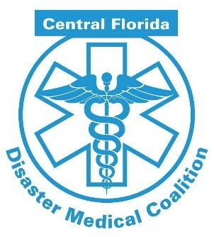

EMS Exercise Roles and Responsibilities

What? The Central Florida Disaster Medical Coalition (CFDMC) will again be hosting the Region 5 full-scale mass casualty medical surge exercise to keep our hospitals and emergency response system ready to respond!

When? The exercise will be held on the morning of Thursday, April 25, 2024. Exercise Play starts at 8 am and ends at noon!

Exercise Webpage! We kindly ask that you not give out the web address to the exercise participants to help ensure a sense of realism. We have created this page so as not to be viewable without the URL to keep key exercise information viewable only to those who need to access it. The web address is: https://www.centralfladisaster.org/atruckloadoftrouble.

Importance of Participation! Most hospitals in the region will be participating in this exercise, with thousands of victim volunteers. Participation of EMS agency vehicles and personnel are vital for a sense of realism at the hospitals and free-standing emergency departments. Participation is also beneficial to EMS for awareness, coordination, and training purposes.

Hospital Expectations of EMS: Our volunteer victims will be pre-staged at or near the receiving facility. EMS will transport victims from staging area to the ER to simulate the transport from the scene of the incident. All victims will have gone thru moulage, received “actor instruction,” and have been assigned a triage tag with the needed triage information. Once EMS picks up the “patient” they read the triage tag and relay a radio report to help stimulate a real-life transport. As part of the simulation, the same EMS unit will transport multiple times from the staging area to the ER with victim volunteer.
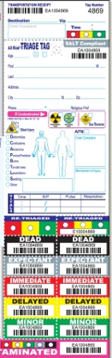

Hospital Controllers: Hospital Controllers will plan and manage exercise play, set up and operate the exercise site, and act in the roles of organizations or individuals that are not playing in the exercise. Controllers direct the pace of the exercise, provide key data to players, and may prompt or initiate certain player actions to ensure exercise continuity. A Hospital Controller has been identified for each participating hospital and will be provided to each EMS agency. The Controller for each facility is listed on the EMS Needs excel sheet located on our webpage for the exercise.

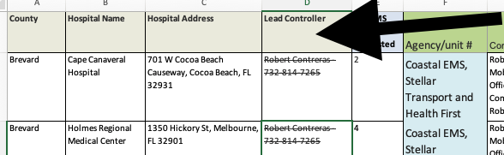

Participating Organizations: There will be approximately 2,000 live victim volunteers from schools across the region going into more than 50 hospitals. There are approximately 100 agencies participating (emergency management, FBI, FDLE, local law enforcement, local fire/rescue/EMS, etc.).

Scenario: The scenario is a complex coordinated terrorist attack with truck bombs at various high traffic/high risk facilities across the region. The trucks will contain hydraulic fluid, requiring decon. The exercise will also include a cyber attack on PACS (hospital imaging system) later in the exercise.

On Duty vs. Stand-by: It is understood that most EMS units participating in the exercise are “on duty” units with real world responses and events. If a real world event occurs requiring the release of the EMS unit , we ask that the EMS unit notify the Hospital Controller.

Assumptions: The exercise will be conducted in a no-fault learning environment wherein systems and processes, not individuals, will be evaluated. Exercise simulation will be realistic and plausible and will contain sufficient detail from which players can respond. Exercise players will react to information and situations as they are presented, in the same manner as if the simulated incident were real.

Artificialities: In any exercise, artificialities may be necessary to complete play in the time allotted and/or account for logistical limitations. Exercise participants should accept that artificialities are inherent in any exercise and should not allow these considerations to negatively impact their participation. During this exercise, the following artificialities apply:
- Exercise communication and coordination will be limited to participating exercise venues.
- Only communication methods listed in the Communications Plan will be available for players to use during the exercise.
- Alerts and injects will be sent via EMResource, text and email through the controllers.
- The exercise will be played in real time; however, some time intervals may be sped up to accommodate schedules and meet exercise objectives.

Exercise Rules: The following general rules govern exercise play:
- Real-world emergency actions take priority over exercise actions.
- Exercise players will comply with real-world emergency procedures, unless otherwise directed by the control staff.
- All communications (including written, radio, telephone, and e-mail) during the exercise will begin and end with the statement “This is an exercise or exercise, exercise, exercise.” Participating agencies may need to balance exercise play with real-world emergencies.
- Real-world emergencies will take priority. Just say Real World!

