ABOUT
The Florida Crisis Response Team, Inc. (FCRT), a state team of
The National Organization for Victim Assistance (NOVA), was established in 1987 as an organization of volunteer crisis interventionists, educators, victim assistance specialists, law enforcement, clergy, and allied professionals, who volunteer their time and talents to assist individuals and communities in Florida.
The FCRT is committed to meeting the emotional needs of
traumatized victims of disasters, crime, and terrorism and is an integral partner in
Florida’s Domestic Security Emergency Support Functions.

Training Announcement and Registration Information
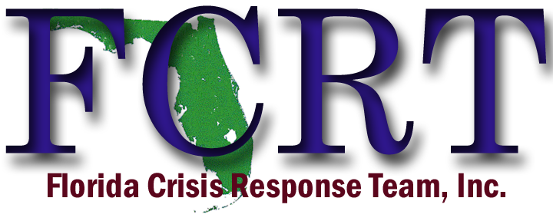
A 40-hour basic NOVA CRT training is being offered in Ft. Myers, FL ~ March 25th – 29th, 2024, to allow individuals the opportunity of receiving the required instruction to become a Florida Crisis Response Team member. The basic CRT training provides a comprehensive study of the elements of the crisis response while also offering practical experience through exercises and skills implementation. Based on a widely accepted model of psychological first aid developed by NOVA, this training allows individuals to respond directly to community and individual crises.

The training will be held each day from 8:00am to 5:00pm.
Registrants must be present each day of instruction in order to become FCRT certified and receive a certificate of course completion.
- Location: SWF Public Service Academy
- Address: 4312 Michigan Avenue, Fort Myers, Florida 33905
- **NO COST**NO REGISTRATION FEE**
- Classroom has limited space, so please register early
- REGISTRATION LINK: https://web.spcollege.edu/survey/36293
- Please email fcrttraining@gmail.com with any questions

**This project is supported by Award #K05551, Office for Victims of Crime, Office of Justice Programs. Sponsored by St. Petersburg College, Center for Public Safety Innovation (CPSI) and the
State of Florida, Office of the Attorney General.**

