Type of Policy: |  | Region 5 emresource policy guideline | Category: | EMERGENCY response
Title: | Non-Emergency Status Update Alerting |  | Policy #: | #9
 |  |  | Replaces #:
Page: | 1 of 1 |  | Developed By: | PSAP SME Group, CFDMC Staff
Issue Date: |  | 4/5/24 | Approved By: | Region 5 EMResource Steering Committee
Revision Dates:

The use of MCI and Hazmat template should be restricted to real world events. Both of these templates ask for ability to handle Red, Green and Yellow triaged patients and to update statuses. Many agency leaders and key partners across the region are set up to receive these for situational awareness.
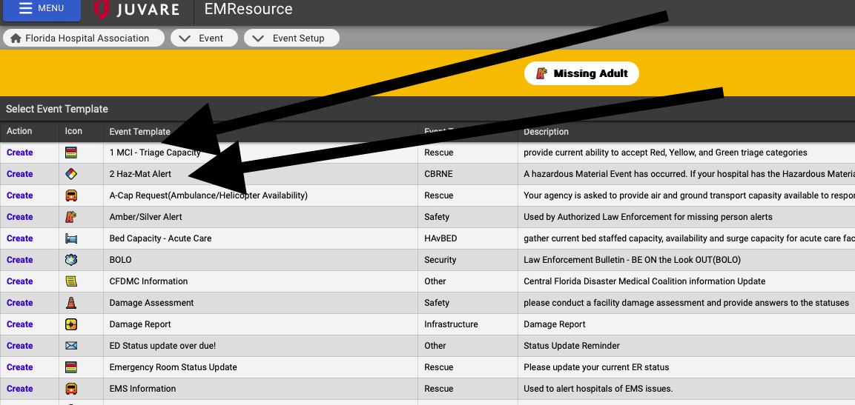

If Alerting for a non-emergency status update, please use the below identified templates.

ED Status Overdue Template is a non-emergency event best used for requesting ED Status and ED Saturation updates:
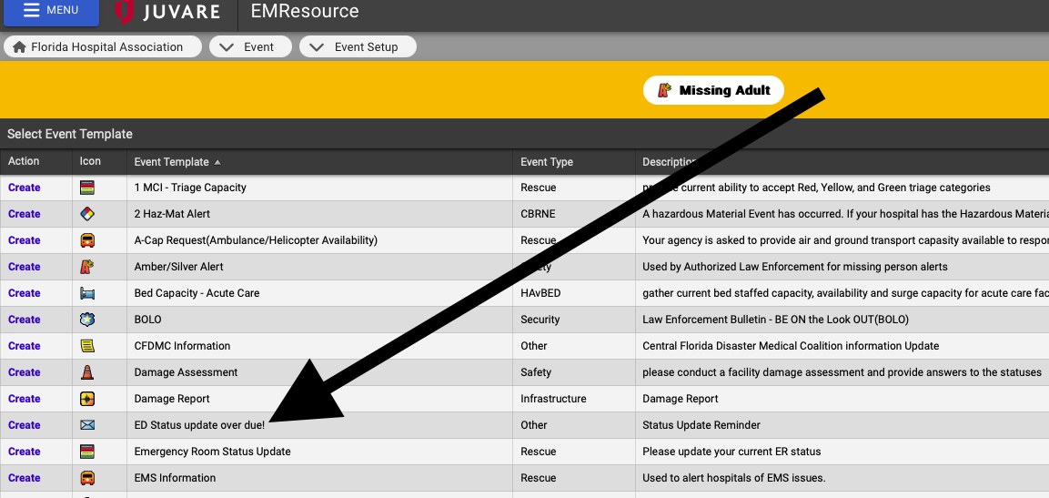

Emergency Room Status Update; is another non-emergency event template to request update statuses. This template requests the update of ED Status, ED Saturation, Hospital Saturation, and Decon statuses.

