Volunteer Management by County: BREVARD

Hospital Name, Address | Hospital Controller (controls exercise play for the hospital for exercise (name, cell #, email) | # Victim Volunteers Requested:  (Total # assigned, including teachers, chaperones) | Assigned School or Agency Point of Contact escorting Victim Volunteers to the hospital (name, cell #, email) | Volunteer Reception Center (victim volunteers, volunteer management and artists report here for check-in, triage tags and moulage)  Address/Room Number:  Reporting time for volunteer management and artists:  Reporting time for victim volunteers:  Volunteer Management Lead (name, cell #, email) | Transportation  Plan  Transportation provider:  Time and location for student pick-up at school/agency:  Location where students are dropped off/picked up at hospital:  Time and location for pick-up at hospital for return to school/agency: | Hospital Staging Area (if different than Volunteer Reception Center)  Address/Room Number:  Hospital Staging Coordinator (name, cell #, email)
Parrish Medical Center  951 N Washington Ave, Titusville, FL 32796 | Leigh Spradling  Leigh.Spradling@parrishmed.com  321-794-4485 | 33  More green triage tag this year please  (33 + 1) | Shanna Mulvany smulvany@keiseruniversity.edu  Students report at 7 am | North Building Conference Room/Breakroom Area  Note: Building is located slightly in front of main hospital. Please have students park in red highlighted parking lot area north of the north building (see map below)  DO NOT GO TO MAIN ENTRANCE OR ED ENTRANCE | N/A – self-transport  *see attached map for parking | Same  Alex Woodring Alex.woodring@parrishmed.com  Cell – 1-407-552-8700
Steward – Rockledge Regional Medical Center  110 Longwood Ave, Rockledge, FL 32955 | Nathalie Abbey  Nathalie.Abbey@steward.org  321-615-7290  Robert Ford  rcford83@gmail.com  321-831-4981 | 30  (33 + 2) | Tammy Harding  hardingt@easternflorida.edu  Students report at 7 am | Cafeteria – ground floor | N/A – self-transport | Private dining room, ground floor  Patrick Dion  321-830-2237  patrick.dion@steward.org
Steward – Melbourne Regional Medical Center  250 N Wickham Rd, Melbourne, FL 32935 | Jo Dee Alverson  Jo.Alverson@Steward.org  208-720-4632 | Triage Tags Only (Paper victims)  14 | N/A | N/A | N/A | N/A

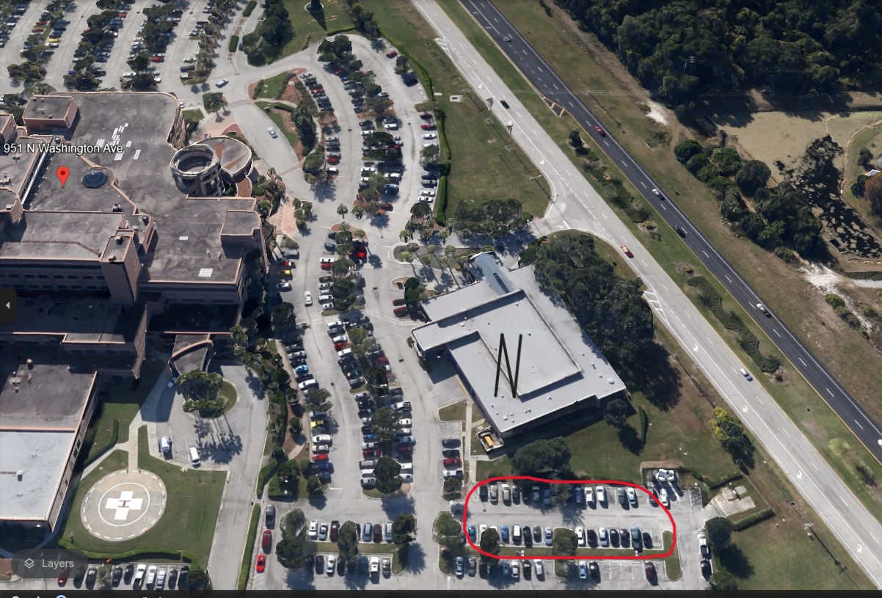
Health First – Cape Canaveral Hospital  701 W Cocoa Beach Causeway, Cocoa Beach, FL 32931 | Withdrew 4/9/24
Health First – Holmes Regional Medical Center  1350 Hickory St., Melbourne, FL 32901 | Withdrew 4/9/24
Health First – Palm Bay Hospital  1425 Malabar Rd. NE, Palm Bay, FL 32907 | Withdrew 4/9/24
Health First – Viera Hospital  8745 N Wickham Rd, Melbourne, FL 32940 | Withdrew 4/9/24

