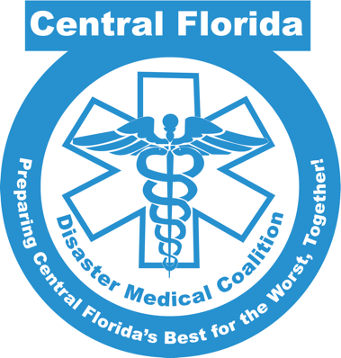

EMResource/Royal 4 New Facility Form

- Facility Name: (should be licensed name)
- Abbreviation; (Max 5 characters)
- Resource Type: ________________
- EMResource users needing to update facility: (At least 1 preferable; list all who update)
- Street Address: ______________________________
- City: _________________________-
- State: _______________
- Zip Code: _______
- County: ______________
- Company/Organization: (Parent company such as HCA or AdventHealth)
- Contact First Name: ____________________
- Contact Last Name: _______________________
- Contact Title: ____________________________
- Contact Phone 1: (e.g. 888-555-1212)
- Contact E-Mail: (e.g. person@example.com)

