Zoom Breakout Rooms Guide
During this exercise there will be opportunities for regional breakout rooms. Please see below the steps for joining a breakout room during the exercise.
- Once the breakout rooms open, an icon entitled: “Breakout Rooms,” will populate in your task bar.

- When it is time to enter the breakout rooms please click on the ‘Breakout Rooms’ button, once you select this, you will be prompted to this menu:
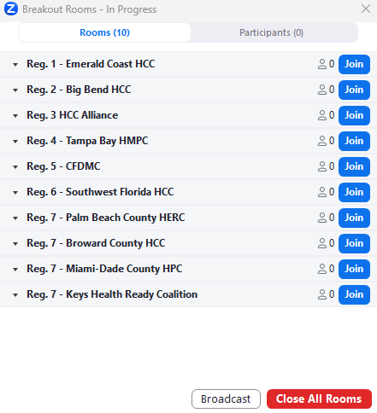

Please click ‘Join’ for your appropriate region.

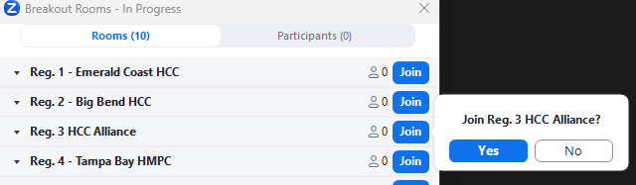
After you select ‘Join’ a different dialogue box will pop up:

Please select ‘Yes’ if that is your region so you will be placed in your correct breakout group. If that is not your region, please select ‘No’ and you will be returned to the main list for you to select your correct region.
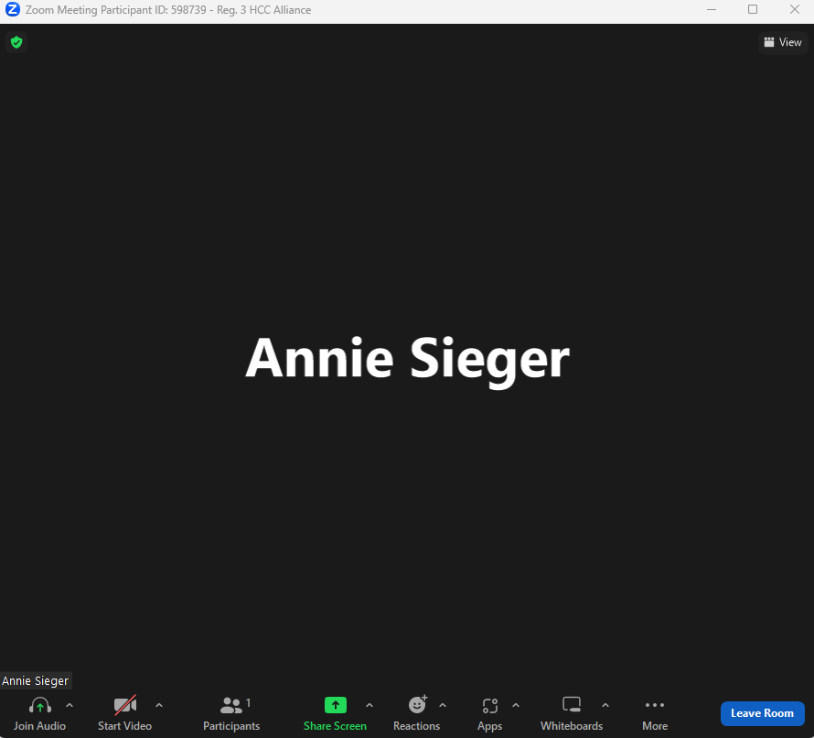
Once in your breakout room you will be able to communicate with your region, and work through the regional discussion parts of the exercise. Your screen should look like this in the breakout room, with the group’s name at the top:

- To leave your breakout room please select the blue ‘Leave Room’ button at the bottom right of your screen.

Please ensure you select ‘Leave Breakout Room' and NOT ‘Leave Meeting.’ If you select ‘Leave Meeting’ you will be removed from the Zoom call.
