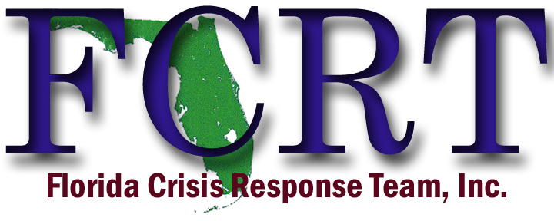
About
The Florida Crisis Response Team, Inc. (FCRT), a state team of
The National Organization for Victim Advocacy (NOVA), was established in 1987 as an organization of volunteer crisis interventionists, educators, victim assistance specialists, law enforcement, clergy, and allied professionals, who volunteer their time and talents to assist individuals and communities in Florida. The FCRT is committed to meeting the emotional needs of traumatized victims of disasters, crime and terrorism.

2026
Training Announcement and Registration Information
Ocala, Florida

A 40-hour basic NOVA CRT training is being offered in:
Ocala, Florida, August 10th - 14th, 2026
The training will allow individuals the opportunity of receiving the required instruction to become a Florida Crisis Response Team member. The basic CRT training provides a comprehensive study of the elements of the crisis response while also offering practical experience through exercises and skills implementation. Based on a widely accepted model of psychological first aid developed by NOVA, this training allows individuals to respond directly to community and individual crises.

- Location: Ocala Police Department
- Address: 402 S. Pine Avenue, Ocala, FL 34471
- **NO COST** NO REGISTRATION FEE**
- Class has limited seating, so please register early
- REGISTRATION LINK: https://web.spcollege.edu/survey/39612
- Please email fcrttraining@gmail.com with any questions

The training will be held each day from 8:00am to 5:00pm.
Registrants must be present each day of instruction in order to become FCRT eligible and receive a certificate of course completion.
**This project is supported by Award #K05909 through the Office for Victims of Crime, Office of Justice Programs.
Sponsored by St. Petersburg College, Center for Public Safety Innovation (CPSI) and the
State of Florida, Office of the Attorney General.**

